

|  |
| --- |
| Municipal Rates Concession for EDA and POW Gold Card holders |
| Accessible application form |
|  |

You can now apply online for this concession. Scan the QR code below or visit [Victorian Concessions and Allowances Portal](https://services.dffh.vic.gov.au/victorian-concessions-allowances-portal) https://services.dffh.vic.gov.au/victorian-concessions-allowances-portal.

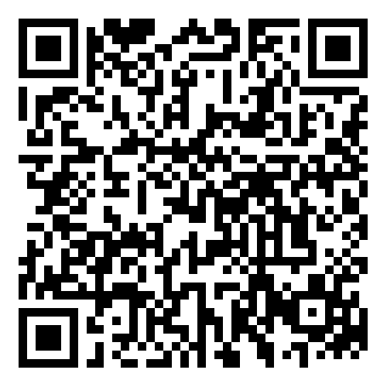

The Municipal Rates Concession for Extreme Disablement Adjustment (EDA) and Prisoner of War (POW) Gold Card holders offers a rebate on council rates, up to a yearly maximum, for eligible cardholders.

Please attach a recent copy of your rates notice.

# Primary applicant’s details

| Information needed | Your response |
| --- | --- |
| **Given names** |  |
| **Surname** |  |
| **Date of birth** |  |
| **Residential address** |  |
| **Suburb/town** |  |
| **Postcode** |  |
| **Email** |  |
| **Preferred phone number** |  |
| **Council** |  |
| **Postal address (if different)** |  |
| **Suburb/town** |  |
| **Postcode** |  |

# Applicant’s concession card type

| Card type | Mark all applicable with an X |
| --- | --- |
| **Gold Card Prisoner of War (POW)** |  |
| **Gold Card Extreme Disablement Adjustment (EDA)** |  |

# Applicant’s concession card number

| Information needed | Your response |
| --- | --- |
| **Veterans’ Affairs file number** |  |

# Applicant’s bank details

Your rebate will be paid into your bank account. Please complete all details.

| Information needed | Your response |
| --- | --- |
| **BSB** |  |
| **Account number** |  |
| **Bank name** |  |
| **Branch name** |  |
| **Account name** |  |

# Consent to check Centrelink details

I authorise:

* the Department of Families, Fairness and Housing (the department) to use Centrelink Confirmation eServices to perform a Centrelink enquiry of my Centrelink or Veterans’ Affairs customer details and concession card status in order to enable the department to determine if I qualify for a concession, rebate or service.
* Services Australia (the agency) to provide the results of that enquiry to the department.

I understand that:

* the agency will disclose personal information to the department including my name, address, payment, concession card type and status to confirm my eligibility for the concession.
* this consent, once signed, remains valid while I am a customer of the department unless I withdraw it by contacting the department or the agency. I can get proof of my circumstances/details from the agency and provide it to the department so that my eligibility for the concession can be determined.
* if I withdraw my consent or do not alternatively provide proof of my circumstances/details, I may not be eligible for the concession provided by the department.
* I understand that the department may disclose personal information from the results of the Centrelink or Veterans’ Affairs enquiry to the Department of Health for the purposes of managing my concessions.

If signing electronically, I confirm that the electronic signature in the consent form represents my signature. I consent to signing the form electronically and I confirm that my signature is legally binding.

| Signature | Date |
| --- | --- |
|  |  |

# Am I eligible for a concession?

To be eligible for a concession you must:

* Hold an eligible concession card:
  + Department of Veterans’ Affairs Gold Card – Prisoner of War (POW)
  + Department of Veterans’ Affairs Gold Card – Extreme Disablement Adjustment (EDA).
* Be the ratepayer listed on the rates account and responsible for payment of the account.
* Make sure that your name and address on the rates account matches the details held by

Veterans’ Affairs.

and

* Not have already received a concession on your municipal rates from your council.

# What do I need to send to you?

Please send us:

1. your completed application form
2. a copy of your municipal rates notice for this year.

# How is the concession paid?

The concession is paid into your nominated bank account.

Once approved, the concession will be paid to you automatically each year, as long as your details have not changed.

# How much is this concession?

The concession amount is indexed every year. Please call the Concessions Information Line on 1800 658 521 (toll free) to find out the current amount.

# Can I send my application by email?

Yes. Make sure you have clearly scanned or photographed your form and rates notice.

Send your documents as attachments to your email, not in the body of the email.

Send your completed application to [Concessions email](mailto:concessions@health.vic.gov.au?subject=EDA-POW%20rates%20concession) <concessions@health.vic.gov.au>.

# How many properties can I claim a concession for?

You can claim for one property only.

The property must be a building fixed to the land and approved by the council for human habitation.

You can only claim a concession for your principal place of residence. For the purpose of this concession, the address linked to your concession card will be considered your principal place of residence.

# Where do I send my form?

Please return your complete form to:

[Email](mailto:concessions@health.vic.gov.au?subject=EDA-POW%20rates%20concession): concessions@dffh.vic.gov.au

Department of Families Fairness and Housing

Concessions

GPO Box 1774

MELBOURNE VIC 3001

# For further information

Please call the Concessions Information Line on 1800 658 521 (toll free).

For help in your language call the Concessions Information Line on 1800 658 521 (toll free) and ask for an interpreter.

# Privacy statement

## Who has access to your information and why?

The department is collecting your information so that we can assess and pay your concession. We may share information with Services Australia to confirm your Veterans’ Affairs details. The Department of Health may also have access to your information for management or operational purposes.

## What happens to your personal information?

Your information will be handled under the requirements of the Privacy and Data Protection Act 2014 (Vic). We will only use this information to assess and pay your concession. We do not disclose your information to any third parties or offshore recipients unless authorised by law. You may withdraw your consent for the department to use your personal information, or this application, at any time. If you choose to withdraw this application, you may not be eligible for the concession.

You can request access to the information we hold about you, and to request that it be corrected if necessary. Please contact the Concessions Information Line on 1800 658 521 (toll free).

|  |
| --- |
| To receive this document in another format, phone 1800 658 521, using the National Relay Service 13 36 77 if required, or email [concessions@dffh.vic.gov.au](mailto:concessions@dffh.vic.gov.au).  Authorised and published by the Victorian Government, 1 Treasury Place, Melbourne.  © State of Victoria, Australia, Department of Families, Fairness and Housing, March, 2025.  Available at <https://services.dffh.vic.gov.au/municipal-rates-concession>. |