

|  |
| --- |
| Non-Mains Life Support Concession |
| Information for concession card holders |
|  |

# Non-Mains Life Support Concession

## What does this concession apply to?

* Electricity accessed via an embedded network
* Non-mains water purchased for domestic use, for example:
  + carted water for rainwater tanks
  + water bought via a billing agent or water cooperative
  + water bought via an embedded network.

Mains electricity customers should see the [Life Support Concession (electricity)](https://services.dffh.vic.gov.au/life-support-concession-electricity) <services.dffh.vic.gov.au/life-support-concession-electricity> and [Life Support Concession (water)](https://services.dffh.vic.gov.au/life-support-concession-water) <services.dffh.vic.gov.au/life-support-concession-water> pages on our website.

## Who can apply for the concession?

An account holder who

* holds an eligible concession card (Pensioner Concession Card, Health Care Card, Veterans’ Affairs Gold Card) **and**
* uses an eligible life support machine **or**
* has a household member who uses an eligible life support machine.

## What machines are eligible for the concession?

Approved machines are those that use at least 1,880 kilowatt hours of electricity annually. Machines approved for the concession are:

* intermittent peritoneal dialysis machines (electricity)
* oxygen concentrators (electricity)
* haemodialysis machines (electricity and water).

## How much is the concession?

In 2025-26, the electricity rebate is $389 and the water rebate is $560.

If the machine was in use for part of the year, the rebate is given from the month it was installed.

The rebate amounts are reviewed each year.

## How do I apply for the concession?

If you have not received the concession before, you will need to ask your doctor to sign the Non-Mains Life Support Concession doctor’s statement before starting your application. The statement is available on our webpage or by calling the Concessions Information Line (see More Information section).

You can apply online in the Victorian concessions and allowances portal. Scan the QR code below or visit go.vic.gov.au/3SkKsbk.

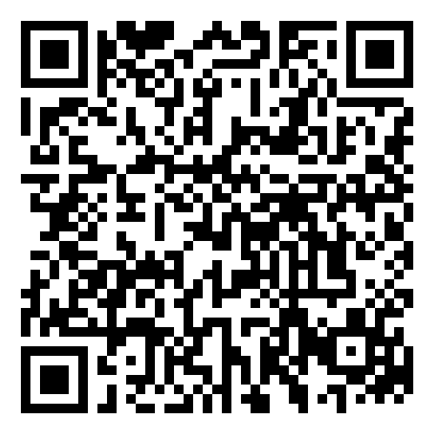

The portal provides an easy, safe and fast way to submit your application.

It also allows you to track your application and see your payments.

Before you start your application, make sure you have all supporting documents ready to upload.

## More information

Phone your water corporation or the Concessions Information Line on 1800 658 521.

# Further information

## Can my GP or usual doctor sign this form?

Yes.

The form can be signed by any doctor or nurse who can confirm that you are using the life support machine, or by a hospital social worker who assists with your life support machine.

## My machine is not listed – is it eligible for a concession?

Eligible machines are those that use a high level of electricity - at least 1,880 kilowatt hours of electricity annually. Only the listed machines are eligible for a concession.

## I do not have a concession card but I use a life support machine – can I apply for the concession?

No.

The concession is only available for concession households.

## Can the concession be backdated?

Yes. The concession can be applied from the date of installation or for 12 months, whichever is shorter.

If your concession card starts at a later date, the concession is only available from the card start date.

## Are there any other payments that can assist me?

Yes. The Essential Medical Equipment Payment is an annual payment provided by Centrelink for Australians with higher-than-average energy costs because they rely on essential medical equipment in their home.

This additional support is available to concession card holders (and their carers) who use essential medical equipment or who medically require heating/cooling at home to manage a disability or medical condition.

For more information and to apply, visit the [Essential Medical Equipment Payment webpage](https://www.servicesaustralia.gov.au/essential-medical-equipment-payment) https://www.servicesaustralia.gov.au/essential-medical-equipment-payment on the Federal Government's Department of Human Services website.

|  |
| --- |
| To receive this document in another format, phone 1800 658 521, using the National Relay Service 13 36 77 if required, or email [concessions@dffh.vic.gov.au](mailto:concessions@dffh.vic.gov.au).  **Help for people with hearing or speech communication difficulties**  Contact us through the National Relay Service (NRS). For more information about the NRS visit [National Relay Service](https://www.accesshub.gov.au/about-the-nrs) https://www.accesshub.gov.au/about-the-nrs, or call the NRS Helpdesk on 1800 555 660.  Authorised and published by the Victorian Government, 1 Treasury Place, Melbourne.  © State of Victoria, Australia, Department of Families, Fairness and Housing, July, 2025.  Available at [Non-Mains Life Support Concession](https://services.dffh.vic.gov.au/non-mains-life-support-concession) <https://services.dffh.vic.gov.au/non-mains-life-support-concession>. |