

|  |
| --- |
| Forensic Disability Access Policy |
| 2025 |
|  |

Contents

1. Context and Scope 3

2. Objective 3

3. Principles 3

4. Referral 4

5. Consent 4

6. Eligibility for Forensic Disability Services 5

6.1.1 Intellectual Disability Criteria 6

6.1.2 Acquired Brain Injury and Neurological Impairment Criteria 6

6.2 Specific considerations when determining eligibility 7

6.3 Information gathering 7

6.4 Outcomes of a request to Forensic Disability Services 7

(a) Accept the request 7

(b) Refuse the request 8

6.5 Requesting a review of target group decision 8

6.6 Statement of Intellectual Disability 8

7. Access to Forensic Disability Services 8

8.Program Specific Priority Indicators 9

8.1 Priority Indicators for Disability Justice Coordination 10

8.2 Priority Indicators for Forensic Disability Clinical Services 10

8.3 Priority Indicators for Specialist Forensic Disability Accommodation 10

8.4 Priority Indicators for a Residential Treatment Facility (RTF) 11

9. Demand Management 12

10. Register of Need 12

11. Vacancy Management 13

Version control and authorisation 14

## 1. Context and Scope

The *Disability Act 2006* (the Act) aims to promote inclusion and active participation of people with disability in their communities and is guided by the principles of human rights. The Act also outlines the legislative requirements for accessing disability services funded and delivered by the Department of Families, Fairness and Housing (herein after referred to as the Department).

The National Disability Insurance Scheme (NDIS) funds disability services and supports for eligible participants; however, there are circumstances where the Victorian Government is responsible for funding and delivering programs and services for people with a disability. The Department funded programs and services include support for people with a cognitive impairment who require specialist forensic support and treatment via forensic disability services.

The scope of this policy applies to all Forensic Disability Services (FDS) which is an umbrella term that encompasses services delivered and funded by the Department. Therefore, this policy applies to those accessing FDS services via government delivered services as well as external agencies that are funded by the Department.

## 2. Objective

The objective of the Forensic Disability Services Access Policy (the policy) is to:

* provide a consistent process for access to forensic disability services, and criteria for determining eligibility and suitability of referrals.
* provide an overview of the definition of disability as outlined in the Act and explain the process for undergoing a target group assessment to determine eligibility for forensic disability services.
* provide people with disability and their support networks with information about how people may access forensic disability services.
* describe the process for determining priority for access to forensic disability services and

registration of need for these services.

## 3. Principles

The principles that guide access to forensic disability services are derived from the Act, specifically section 5 which outlines principles that relate to people with disability. These principles include that people with disability have the same rights as other community members to participate actively in decisions and be provided appropriate information and support necessary for this to occur.

Forensic disability services are a statewide service that aims to be flexible and responsive, maximise choice and independence, and foster collaboration, coordination, capacity building and integration with local services and where possible minimise the need for an individual to move out of their local community to receive these supports. In this vein, forensic disability services acknowledge the important role that families and carers play in supporting people with disability.

Consideration to the marginalisation of individuals and how this may affect their access and engagement with services is another guiding principle. The reality that people with disability may experience increased disadvantage because of their gender, sexual orientation, language, cultural or indigenous background, or location is a core principle of the access policy.

The Secretary of the Department has legislated responsibilities under the Act that are reflected in this policy. These responsibilities are commonly undertaken by the Secretary’s delegate as detailed in the Instrument of Delegation, *Disability Act 2006* and these responsibilities underpin the principles of this policy.

## 4. Referral

Referrals to forensic disability services may be received from several sources, including:

* mandated by a court or statutory authority
* made directly by the person with a disability
* referred by a professional or support worker of the person with disability

Forensic disability will first establish a person’s eligibility in accordance with the Act (see section 6) and then determine whether the person with disability is considered to meet the priority of access criteria and any program specific priority indicators before a referral to forensic disability programs is made (see sections 7 and 8).

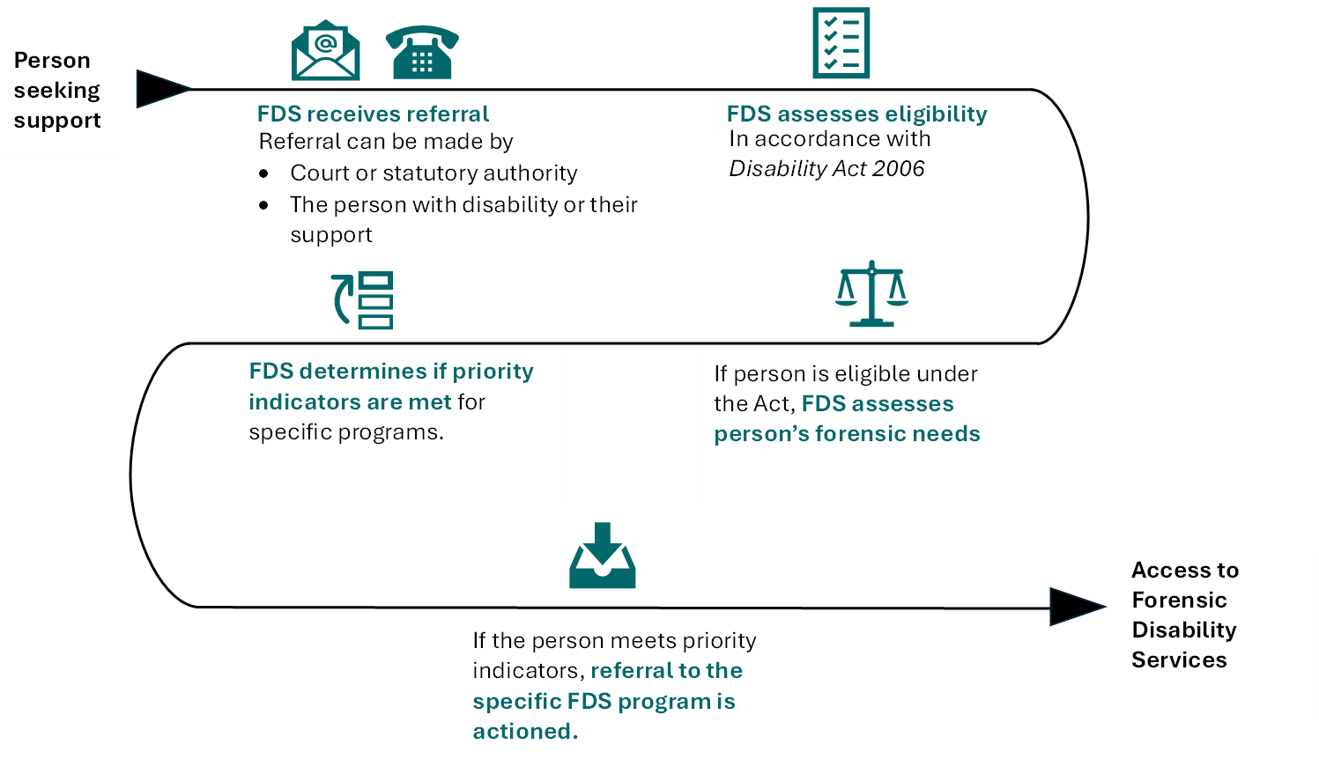

## 5. Consent

Consent is required, in accordance with Section 50 (3) of the Act, to both gather and share personal or health information. The person making the request should ensure that the person with disability (or their legal guardian if appropriate) is informed, in a way they can understand, why this information is being requested, and how it will be used, shared, and stored. Part 8A of the Act protects what information can be shared and for what reasons.

Many people involved with forensic disability services are mandated by a court or statutory authority. Where the request for service is made by a court or statutory authority, consent is implied as this is required to be considered during the court assessment process. However, it is best practice for forensic disability services to confirm the consent of the person with disability (or their legal guardian) at the time of commencement of a service.

It is crucial to support the person with disability to understand the court’s mandated request and expectations. Any person has the right to refuse consent and choose not to participate in services ordered by the court, however all attempts should be made to inform the person of the (potential) consequences of such a decision.

People with a cognitive impairment involved in the criminal justice system or at risk of involvement with the criminal justice system may also provide consent to voluntarily engage with forensic disability services.

## 6. Eligibility for Forensic Disability Services

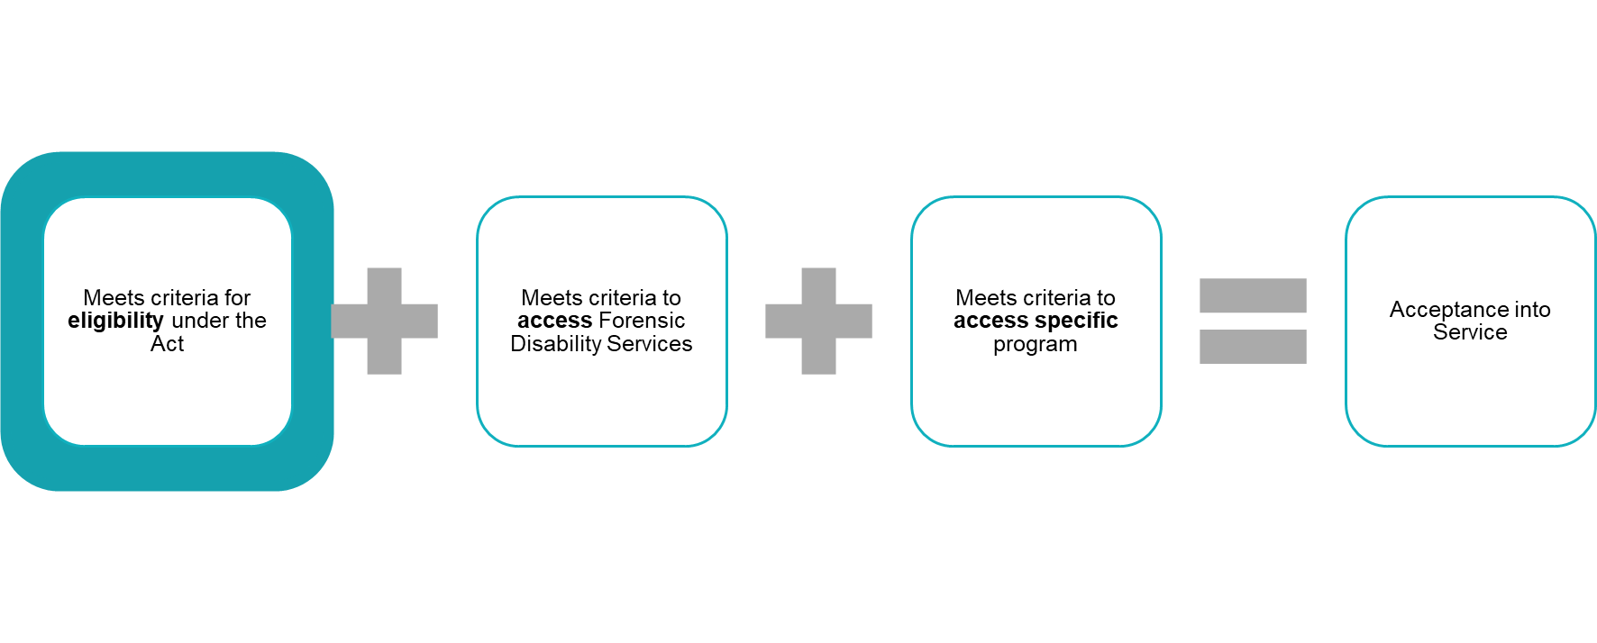This policy and eligibility to forensic disability services is governed by disability as it is defined in section 3 of the Act:

Disabilityin relation to a person means *–*

1. A sensory, physical or neurological impairment or acquired brain injury or any combination thereof, which
2. Is, or is likely to be, permanent; and
3. Causes a substantially reduced capacity in at least one of the areas of self-care, self-management, mobility or communication; and
4. Requires significant ongoing or long-term episodic support; and
5. Is not related to ageing; or
6. An intellectual disability; or
7. A developmental delay.

Within the broader group of persons with disability under the Act, services provided by forensic disability services are also available to people with a cognitive impairment who are in contact with, or at risk of being in contact with the justice system. Cognitive impairment is used to refer to types of disabilities that impact cognitive functioning including intellectual disability, acquired brain injury and some types of neurological impairment. To access forensic disability services, an individual must be determined as being within the target group as defined by the Act:

|  |  |
| --- | --- |
| ***Included in Forensic Disability Services***  ***Target Group:*** | ***Excluded from Forensic Disability***  ***Target Group:*** |
| Intellectual Disability | Physical Disability Only |
| Acquired Brain Injury | Sensory Disability Only |
| Neurological Impairment |  |

**Age Restrictions:**

Access to forensic disability services is available to children aged over 10 years with a disability. Any treatment and support offered by forensic disability services to a child with disability aged between 10 and 14 years will be provided within the context of early intervention.

For a person with disability who is aged 65 years or over, it is important to consider what the person’s primary need is and how that need can best be met, particularly if they are accessing for the first time. Forensic disability services must carefully consider if they meet the priority of access criteria or whether aged care services are more appropriate to meet the support needs of the person.

#### 6.1.1 Intellectual Disability Criteria

In determining whether a person meets the criteria for an intellectual disability within the Act, forensic disability services will consider a person's developmental history, education and vocational background, the level of support required with cognitive and adaptive tasks, in addition to cognitive and adaptive assessments.

|  |  |
| --- | --- |
| **Intellectual Disability (ID) criteria** | **Supporting Evidence** |
| * is the person over the age of 5 years, & * has a significant sub-average general intellectual functioning, & * has significant deficits in adaptive behaviour.   (with the last two present before age 18) | * Previous Cognitive Assessments * Adaptive Behaviour Assessments * Self-Report or Carers Observations |

#### 6.1.2 Acquired Brain Injury and Neurological Impairment Criteria

An acquired brain injury (ABI) is damage to the brain that occurs after birth and is not related to congenital or degenerative disease. Damage may be caused by a traumatic head injury or a non-traumatic cause. The existence of an acquired brain injury, as well as an associated cognitive impact must be present for the criteria to be met.

A neurological impairment is a disturbance in the structure or function of the nervous system resulting from developmental differences, disease, injury or toxin. Different neurological impairments will impact people in different ways resulting in people experiencing difficulties in a range of life areas, some of which may be specific to a particular disorder.

Autism Spectrum Disorder (ASD) is considered a neurological impairment within the definition of the Act. ASD refers to a range of neurodevelopmental disabilities characterised by significant challenges in social interaction, communication, and restricted repetitive behaviours, interests, and activities.

|  |  |
| --- | --- |
| **Acquired Brain Injury (ABI) or Neurological Impairment criteria** | **Supporting Evidence** |
| * Is, or likely to be, permanent * Causes substantially reduced capacity in at least one of the areas of self-care, self-management, communication and/or mobility. * Requires significant ongoing or long-term episodic support * is not related to ageing | * Specialist Medical Reports * Diagnostic Assessments * Neuropsychological Assessments. * Allied Health Reports * Self-Report or Carers Observations |

### 6.2 Specific considerations when determining eligibility

When a person is referred to forensic disability services with a known or suspected circumstances such as a mental health condition, chronic health needs, substance use or age-related issues this must be considered when making decisions about a person having a disability. Cognitive testing must endeavour to distinguish between the impact of the disability and any other associated condition/s. On these occasions, it is advisable to include at least one practitioner with expertise in the other areas of need during the assessment period.

Consideration should also be given to the timing of any testing and decision-making. Where a person is experiencing a mental health episode or substance use relapse, any decision should be delayed until this has stabilised.

### 6.3 Information gathering

When a request for forensic disability services has been made, information is gathered, with the persons consent (as required by section 50 of the Act), to determine:

* if the person is eligible under the *Disability Act 2006*
* if the person has forensic needs or involvement with the criminal justice system
* the appropriateness of forensic disability services to provide the services
* if the person is a priority for access to forensic disability services (see Section 6).

After reviewing the information, the Secretary or their delegate, may decide that a formal assessment is required. If this is the confirmed course of action, the assessment must be commenced within 30 days of that decision. However, the assessment may be deferred for up to three months where there are reasonable grounds to believe that a formal assessment completed before then is unlikely to reliably establish whether the person has a disability, such as when a person is experiencing a mental health episode or substance use relapse.

### 6.4 Outcomes of a request to Forensic Disability Services

Upon receipt of a referral, the Secretary or delegate, can:

* either accept or refuse the person’s request to forensic disability services.
* Within 14 days of making the determination, the Secretary must notify in writing to the person making the request and the person about whom the request was made.
* This notice must also inform the person that they can apply to Victorian Civil Administrative Tribunal (VCAT) for a review of the decision within 28 days.

#### (a) Accept the request

The Secretary may require a person to provide more information or undergo a target group assessment to determine whether the referral is to be accepted. A maximum of six weeks is allowed to complete this process. Accepting a request does not mean the person will be able to access the requested forensic disability services program, as the person must also meet the priority indicators and program specific criteria.

#### (b) Refuse the request

The Secretary may refuse the request, if so, the notification to the person must include the reasons for refusal.

### 6.5 Requesting a review of target group decision

Under section 50A in the Act, a person can request a review by VCAT of the Secretary’s decision as to whether a person has a disability. If this review is to occur, the person must apply to VCAT within 28 days of the Secretary’s communication of the decision.

The Act states that on reviewing the decision, VCAT may:

* confirm the decision of the Secretary
* return the matter to the Secretary for further consideration
* make its own decision as to whether the person has a disability.

### 6.6 Statement of Intellectual Disability

Courts or tribunals may seek clarification as to whether a person has an intellectual disability at any time, not just during the referral process. If the Secretary is satisfied that a person has an intellectual disability as defined under the Act, the Secretary may provide a written Statement of Intellectual Disability. This is stated in section 6 of the Act.

## 7. Access to Forensic Disability Services

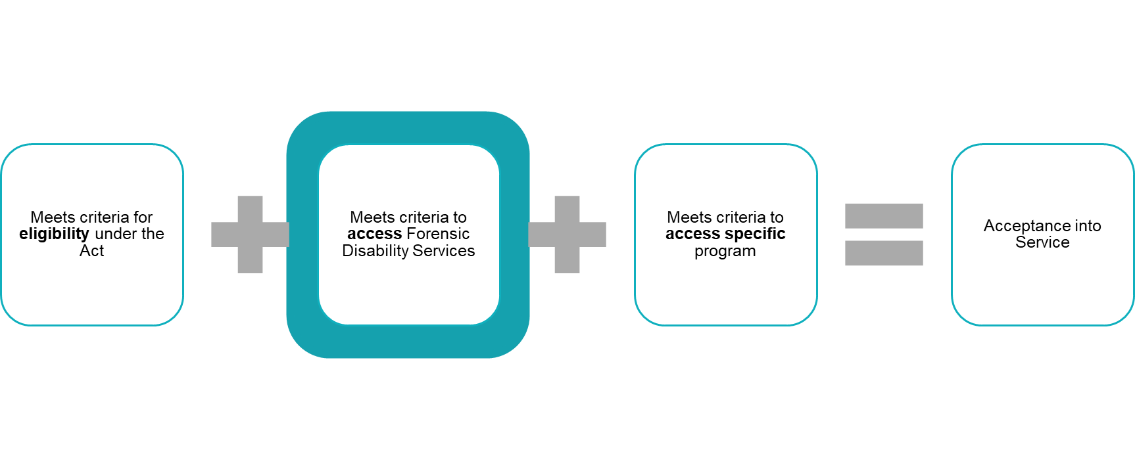

Access to forensic disability services is managed through a coordinated process within the Department. After establishing eligibility under the Act, access to services is determined based on a set of priority indicators. These priority indicators assess whether the person with a disability has a current need for service and if forensic disability services is best suited to meet that need.

Clear information about the principles, indicators, program specific criteria and process for determining the priority of access to forensic disability services must be readily available in appropriate formats and languages.

7.1 Suitability of Service

Access to forensic disability services should only be provided if it is determined that the individual’s support needs are unable to be met outside of forensic disability services programs.

7.2 Priority Indicators for Access

Decisions about allocating forensic disability services support will balance the needs of the person with the demand for the service, and must be efficient, equitable and maximise options for the person’s independence and promote their safe participation in the community.

Priority indicators for access to FDS:



## 8.Program Specific Priority Indicators

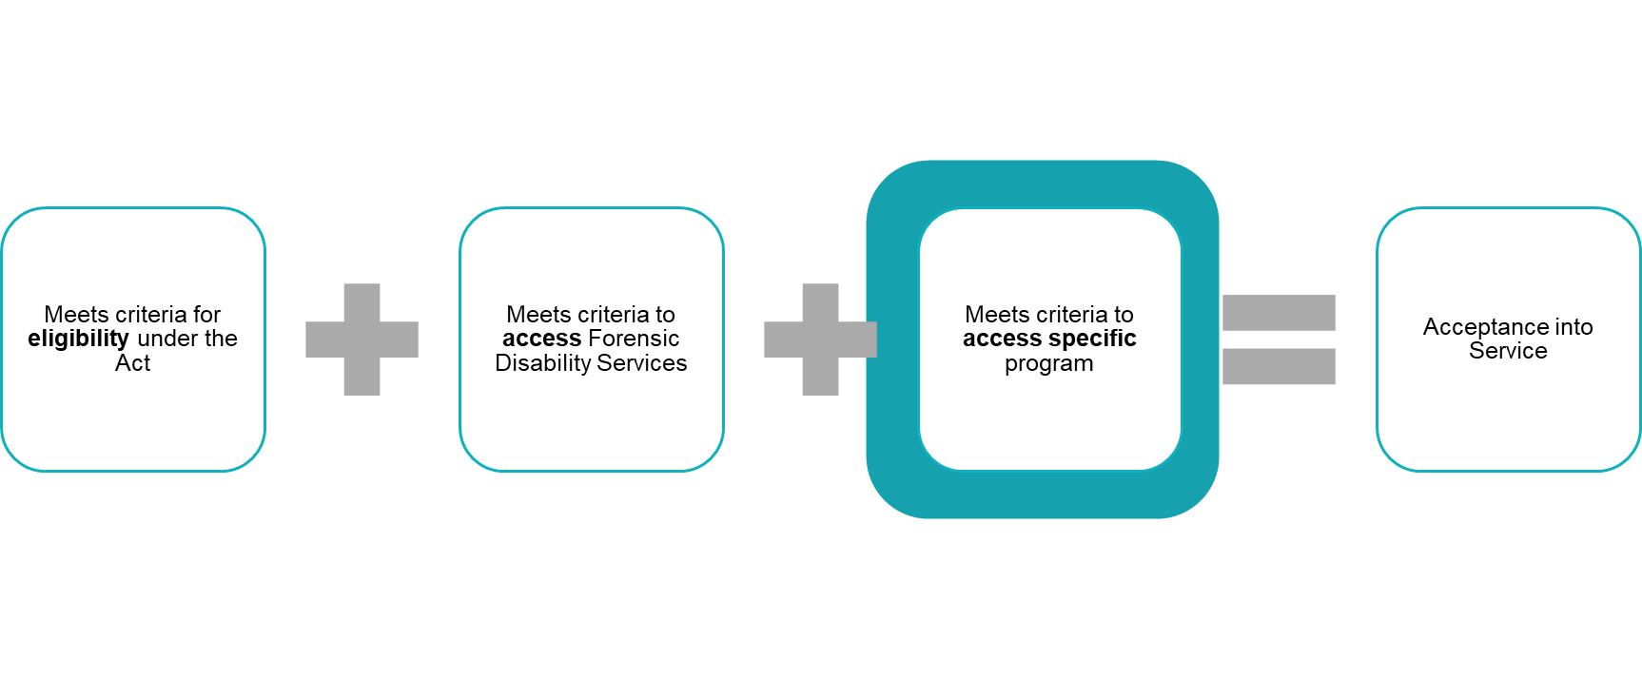

Some service offerings within forensic disability services are limited by legislation to people subject to specific orders. Similarly, certain services within forensic disability services have further eligibility criteria known as program-specific priority indicators.

### 8.1 Priority Indicators for Disability Justice Coordination

The Disability Justice Coordination (DJC) service:

* assesses and coordinates forensic disability supports based on the person’s needs, risks and goals.
* supports access to other support services the person requires.
* provides information in an accessible format and supports the person with disability to understand the court process, conditions of bail, parole and/or other orders.
* coordinates access to interventions to reduce their risk of (re)offending and any behaviours of concern, improve their quality of life and support community safety.

DJC program priority indicators for referrals include:

* a Court has ordered the referral, such as through a Justice Plan
* if the person has complex support and service coordination needs and requires specialist support from DJC, where all other supports have not been able to meet the need/s of the person.
* if the person is engaging in high-risk offending behaviour and/or high-risk behaviours of concern that are placing them at significant risk of interaction with the criminal justice system.

### 8.2 Priority Indicators for Forensic Disability Clinical Services

The Forensic Disability Clinical Services (FDCS) provides offence-specific and offence-related treatment programs that

* are targeted to people with cognitive impairment who would otherwise not be able to effectively engage in mainstream offender treatment and rehabilitation services
* address behaviours of concern related to the person’s disability and aim to reduce their risk of offending
* are provided in forensic residential settings and in community-based settings
* are provided online or face-to-face.

Priority indicators that will be considered when seeking services from Forensic Disability Clinical Services include:

* requests directed or recommended by a court and/or Justice Plan
* requests for Residential Treatment Facility (RTF) eligibility assessments
* requests for current RTF residents
* requests for current Specialist Forensic Disability Accommodation (SFDA) residents
* risk of offending and community safety.

### 8.3 Priority Indicators for Specialist Forensic Disability Accommodation

Specialist Forensic Disability Accommodation (SFDA) provides non-secure accommodation for people with forensic disability treatment and support needs who require a residential setting to reduce their behaviours of concern and/or their risk of (re)offending. SFDA is delivered as a blended funding model with the NDIS.

SFDA aims to

* increase the person’s adaptive functioning skills and achieve personal goals with clinical treatment provided through psychologists.
* provide a therapeutic environment, integrating forensic clinical intervention and NDIS-funded disability direct care supports, to support the achievement of beneficial treatment outcomes and goals.
* stabilise the person’s living arrangements, develop independent living skills, support their treatment goals and prepare for transition to longer-term housing.

SFDA priority indicators include:

* at risk of remaining in a custodial or secure setting for longer than necessary and require SFDA to enable reintegration into the community.
* currently in an accommodation option that significantly increases their risk of offending or behaviour of concern.
* at risk of experiencing harm from other residents in current living arrangements, including family violence.
* experiencing environmental instability, impeding their ability to engage in forensic disability support and treatment (this may include homelessness).
* unable to access alternative accommodation options due to forensic disability support and treatment needs.
* requiring SFDA as a condition of an order under the *Crimes (Mental Impairment and Unfitness to be Tried) Act 1997* (CMIA) and other community-based court orders.
* stepping down from placement in a Residential Treatment Facility.
* in need of full-time access to support in an accommodation setting because of forensic disability support and treatment needs.
* disability support needs will be met and funded by their NDIS plan
* in frequent contact with the criminal justice system.

The progress of residents in SFDA is tracked and reviewed by the care team, who work collaboratively with the residents to facilitate their transition to less restrictive and more independent community living options.

### 8.4 Priority Indicators for a Residential Treatment Facility (RTF)

Residential Treatment Facilities (RTF) are secure facilities where a person receives intensive treatment whilst residing in the facility due to conditions of their court order. Operating under the Act, these facilities provide therapeutic intervention programs, treatment, and skill development within a structured and secure environment.

Admission criteria for RTFs are legislated under section 152 of the Act, and require that:

* the person is an adult with an intellectual disability; and
* the person presents a serious risk of violence to another person; and
* all less restrictive interventions have been tried or considered and are not suitable; and
* the RTF can provide suitable treatment having regard to the person’s willingness to engage in and benefit from the treatment; and
* the person can engage in the therapeutic environment at the RTF; and
* admission is appropriate having regard to the level of vulnerability of the person, any risks they present to other residents of the facility and compatibility with other residents of the facility; and
* the Secretary has arranged for the person to undergo an assessment; and
* the Victorian Senior Practitioner has been consulted; and
* the person is subject to one of the following orders, with the condition to reside at the RTF:
  + Residential Treatment Order under the *Sentencing Act 1991*
  + Parole Order under the *Corrections Act 1986*
  + Custodial Supervision Order under the *CMIA*
  + An Order transferring the person from a prison under the *Act*
  + A Supervision Order or Interim Supervision Order within the meaning of the *Serious Offenders Act 2018.*

In addition to the legislated requirements, RTF priority indicators include:

* Where there is increased possibility of imprisonment for a person subject to or being considered for an Order under the CMIA, as this Act acknowledges prison is to be a last resort for people found either unfit to stand trial or not guilty of an offence on the grounds of mental impairment.

## 9. Demand Management

Referrals to Forensic Disability Services will be actioned when it has been established that the person meets the eligibility requirements and satisfies the specific priority indicators. The length of time a person has been waiting for Forensic Disability Services is not a consideration for demand management.

Forensic Disability Services programs are required to acknowledge and take necessary action within 14 days of receiving a referral. Capacity and demand of the programs will determine whether an immediate allocation is possible. The specific service must contact the person with disability regularly to keep them informed of the status of their referral and when supports can be expected. Any change in circumstances that increases the urgency of the referral should also be reported to the program area by the referrer or person seeking support.

## 10. Register of Need

The department directly delivers and funds the provision of forensic residential services. A register of eligible referrals will be maintained, known as the Register of Need.

The Register of Need is used to record a person’s current need for forensic residential services, against the residential services criteria. It provides a clear and accurate record of the support required and enables the efficient identification of those in need so vacancies can be allocated in a fair, transparent, and efficient manner by matching a person’s current need against existing service profiles.

To ensure requests remain relevant and actively reflect the person’s circumstances, referrals recorded on the register of need must be reviewed regularly or when any of the following situations occur:

* The person advises that their support needs or circumstances have changed (including contact with the Department by the person, their authorised representative, or their Disability Justice Coordinator)
* The person’s NDIS plan has been reviewed
* A lapse of 6 months has occurred since a review of the person’s referral.

## 11. Vacancy Management

The providers of residential services must inform the Department about expected timelines for any vacancies, including any changes or transition plans occurring. When a resident has vacated their room and it becomes available, the vacancy is declared.

When a vacancy is declared:

* the Register of Need is consulted, and applications assessed against the house profile and current resident compatibility criteria, suitable applicants are shortlisted
* for RTF, an eligibility assessment will be undertaken by Forensic Disability Clinical Services
* a vacancy meeting is convened to discuss shortlisted applicants and determine who is most suitable for the vacancy. The vacancy meeting requires a quorum to determine the suitable applicant.

After determining a suitable applicant, an offer is made. On acceptance of the offer, transition planning will begin. The timeframe for the person to move into the property should not exceed 60 days from the acceptance of the offer. If the offer is declined, the shortlist will be reconsidered through the vacancy meeting.

**Appendix 1: Acronyms**

|  |  |
| --- | --- |
| **Acronym** | **Meaning:** |
| ABI | Acquired Brain Injury |
| ASD | Autism Spectrum Disorder |
| DFFH | Department of Families Fairness and Housing |
| DJC | Disability Justice Coordination |
| FDS | Forensic Disability Services |
| FDCS | Forensic Disability Clinical Services |
| FRS | Forensic Residential Services |
| ID | Intellectual Disability |
| SFDA | Specialist Forensic Disability Accommodation |
| RTF | Residential Treatment Facility |

**Appendix 2: Glossary of Terms**

|  |  |
| --- | --- |
| **The Department** | Refers exclusively to the Department of Families Fairness and Housing |
| **Forensic Disability Services** | Umbrella term used to refer to disability services provided under the *Disability Act 2006*, these services under FDS refer to those funded or delivered by the Department. |
| **Cognitive Impairment** | Umbrella term used to refer to disability types which have an impact on cognitive functioning including intellectual disability, acquired brain injury, or some neurological impairments. |
| **Secretary** | Refers to the Secretary of the Department of Families, Fairness and Housing or the Secretary’s delegate being the position nominated to exercise specific powers assigned to the Secretary of the Department, via the Instrument of Delegation for the *Disability Act 2006.* |
| **Target Group Assessment** | An assessment to determine disability in accordance with criteria outlined in the *Disability Act 2006*. |
| **Victorian Senior Practitioner** | Victorian Senior Practitioner as per the *Disability Act 2006*. |

Version control and authorisation

|  |  |  |  |
| --- | --- | --- | --- |
| Authorisation status/date | | |  |
| **Version** | **Status** | **Approval Date** | **Approving Author** |
| Version 1.0 | Final | 22 April 2025 | Executive Director, Disability Reform and Complex Needs |
| Version 1.0 | Final | 30 April 2025 | Complex Needs and Forensic Disability Steering Committee |

|  |
| --- |
| To receive this document in another format, email Disability Reform and Complex Needs Branch <drcn@dffh.vic.gov.au>.  Authorised and published by the Victorian Government, 1 Treasury Place, Melbourne.  © State of Victoria, Australia, Department of Families, Fairness and Housing, June 2025.  Available at Department of Families, Fairness and Housing <http://www.dffh.vic.gov.au> |